Reconstructing Ukraine:

An Incentive-Based Approach

Lead authors:

Charles Becker, Peter Devine, Aaron Lam, Michelle Schultze, and Eva Spektorov[1]

With a contribution from:

Jon Queen

August 12, 2024

## Abstract

This paper emphasizes a reconstruction strategy that focuses on incentives – for businesses to invest and for workers to return to Ukraine. As such, it complements the dominant approach that emphasizes large capital transfers and reparations, with an implicit underlying assumption that massive capital flows will draw in businesses and workers. We argue that stable, long-term external guarantees – in essence, insurance policies – are necessary to achieve stable, long-term growth, as opposed to cyclical booms and busts, and also to contain corruption. Not only will these guarantees bring greater stability and growth to Ukraine, they may well be far more cost-efficient to Western taxpayers.

Acknowledgements

We gratefully acknowledge valuable data assistance from the staff at [www.work.ua](http://www.work.ua), as well as exceptionally useful commentary on earlier drafts from General Philip Breedlove and Professors Michael Connolly, Patrick Duddy, Edward Tower, Volodymyr Vakhitov, and Nataliia Zaika. All omissions, misinterpretations, errors, data and econometric flaws, and other limitations are solely our own.

## Introduction: the problems

This paper emphasizes a reconstruction strategy that focuses on incentives – for businesses to invest and for workers to return to Ukraine. As such, it complements the dominant approach that emphasizes large capital transfers and reparations, with an implicit underlying assumption that massive capital flows will draw in businesses and workers. We do not claim that these forces are unimportant, especially with respect to building social and physical infrastructure, demining, and efforts to support agriculture and generate business credit.[2] However, state-driven international assistance and reparations alone will not lead to recovery: an effective program must also attract labor and private capital.

Such refugee repatriation and private capital inflows are particular important for Ukraine. Prominent Ukrainian demographer Ella Libanova (2023) forecasts a decline in population to as little as 30 million by 2035, leading to panicked media stories about “catastrophic” labor force declines ([Демографи прогнозують, що у 2023 році на Україну чекає катастрофічне падіння народжуваності (ukrinform.ua)](https://www.ukrinform.ua/rubric-society/3641463-demografi-prognozuut-so-u-2023-roci-na-ukrainu-cekae-katastroficne-padinna-narodzuvanosti.html))

Indeed, Ukraine’s population was shrinking even prior to the 2022 invasion. Standardized mortality rates were high relative to regional comparators; birth rates (total fertility rates) were low, and below replacement levels. Because of the 1990s post-Soviet collapse in fertility, entering labor force cohorts have been unusually small; given delayed fertility, crude birth numbers would be especially small in the early 2020s even in the absence of an invasion. Tverdostup’s (2023) detailed demographic analysis notes that Ukraine’s population already had declined by 20% from (roughly) Independence to 2023, to a level just under 38 million – and with further gradual declines on the horizon even if the war ends without a period of escalation.

Compounding the demographic crunch, the UNHCR estimates that there were 6.484 million external refugees from Ukraine as of mid-May 2024 [Situation Ukraine Refugee Situation (unhcr.org)](https://data.unhcr.org/en/situations/ukraine). Virtually all of the net flow occurred in early 2022. Added to that, the UN’s International Organization for Migration (IOM) estimates that there were 3.314 million internally displaced persons in Ukraine as of June 2024 [Ukraine | Displacement Tracking Matrix (iom.int)](https://dtm.iom.int/ukraine).

The Russian invasions of 2014 and, especially, 2022 substantially disrupted the remaining labor force and employment as well. Casual review of state labor force data (jobs vs. job seekers by profession: <https://www.dcz.gov.ua/stat/statfile>) suggest greatest relative demand for skilled labor rather than unskilled labor or administration. The detailed micro data from [www.work.ua](http://www.work.ua) discussed below confirm this impression.

In response, there has been substantial effort from both the Ukrainian Government and private voluntary organization to retrain the large un- and under-employed working-age population in Ukraine. Of the 93,000 Internally Displaced Persons who received assistance from government employment assistance programs in May-June 2023, the PVO Stabilization Support Services (2023) found that approximately half had since found employment.

Even prior to the Russian invasions, Ukraine had low levels of both domestic and foreign direct investment relative to comparator countries such as Poland and Turkey (for detailed analyses see Movchan and Rogoff (2022) and other chapters in Gorodnichenko et al., (2022)). A litany of problems, starting with corruption, state interference, insecure property rights, distance from markets, infrastructure gaps, and, to paraphrase Porfirio Diaz, “Poor Ukraine – so far from God, so close to Russia,” deterred those with limited appetite for risk. The seizure of key parts of heavy industrial areas in or near the Donbas has been a further, crippling blow.

Ukraine’s policy responses, especially since early 2022, have been in the right direction, but war-related destruction and uncertainty will deter prospective investors for years to come. Corruption has been reduced despite the war (which offers an invitation to theft) and public policies have become more investor-friendly. However, as we suggest below, there are additional key steps that can be taken to encourage both local and international investment.

Although access to both labor and capital are severe barriers to Ukraine’s long-term recovery, the situation has many bright areas as well. Despite the war, 2023 witnessed large numbers of newly registered small-scale enterprises (“fop”s, the majority of which were opened by women) and formally registered companies <https://opendatabot.ua/analytics/foponomics-2023-12>. Unfortunately, very few new small or large companies were in industry or mining, and these new ventures were overwhelmingly concentrated in Kyiv, Lviv, and Dnipro.

Further positive news is that over 2,600 companies have been started in Ukraine by foreigners since February 2022 (<https://opendatabot.ua/analytics/foreigners-business-per-war>). The largest number of investments has been from Turkey, followed in order by Uzbekistan, Poland, USA, Kazakhstan, Germany, Azerbaijan, Israel, and the UK. The largest single investor is an Armenian construction company. A wealth of information can be found at <https://opendatabot.ua/analytics>; an overview of international financial institution commitments can be found in Sologub (2024); and the current, modest effort by USAID is described [here](https://www.usaid.gov/uk/ukraine/economic-growth).

1. Strategic responses

Creating a healthy economic environment is critical for Ukraine’s long run economic success. Helping design the right structural incentives is a key part of international assistance, and may be *the* key part. Our point of departure is the “[peace engineering](https://archivist.atlantaglobalstudies.gatech.edu/peace-engineering-an-emerging-field/)” approach pioneered by General Philip Breedlove and Prof. Joseph Hughes at Georgia Tech. Briefly, technical “engineering” solutions must be paired with analysis of agents’ incentives – as economists would say, principal-agent and moral hazard problems must be confronted head-on. In addition to military success, demining, rebuilding infrastructure, and financial support, rebuilding Ukraine requires both a secure environment and rule of law. We focus below on key mechanisms that make these additional requirements attainable.

Measures aimed at stabilizing and strengthening the Ukrainian economy, beyond the vast set of structural changes and policy measures set forth in Gorodnichenko et al. (2022) and in VoxUkraine reports, fall into three broad categories. While there are obvious overlaps, we divide incentive measures into those aimed at attracting and reintegrating refugees, those aimed at attracting physical capital investment, and those with broad stabilizing effects that will reassure and attract both workers and investors. These measures are outlined in the following paragraphs. Background discussions follow concerning Ukraine’s labor market, investment patterns, assessments of the consequences of reopening airports, and other countries’ experiences with currency boards.

**II.1. Rebuilding Ukraine’s labor force**. To attract returning refugees, once fighting is ended or contained, people must need to believe that they have a secure option in the event of further fighting or economic collapse. In addition to Ukrainian government efforts, there are several things that international supporters can do:

* + Guarantee pension entitlements, whether defined benefit or defined contribution, from earnings already accumulated outside of Ukraine, and make them portable.
  + Give work-years-in-Ukraine credit to entitlements in supporter countries, where *m* years of work in Ukraine entitles a person (and family members) to *n* years of authorized residency and ability to work (and accumulate pension assets) in supporter countries, as well as *p<m* years of minimum retirement benefits and/or healthcare benefits in supporter countries.
  + Guarantee housing, health, schooling, and welfare payments to family members who have fled and are not in the labor force, for a transition period. Family services in particular are a crucial barrier to achieving desired replacement fertility rates in resource-poor areas (Prata et al., 2009)

The motivation for these guarantees is that they reduce refugees’ risks of returning home, and provide supplemental incentives that, beyond monitoring costs, have almost no immediate budgetary consequences for contributing nations. Furthermore, the greater the uptake of programs along these lines, and hence the larger the return flow, the less likely it will be that former refugees will return and impose costs on contributing nations. A further psychological benefit is that such measures more strongly link Ukraine to central and western Europe and, ultimately, increase the likelihood of EU accession.

Judging from the results of the VoxUkraine survey of refugees discussed in Zaika and Vakhitov (2024), it appears that those least likely to returned home are younger refugees with higher levels of education and better earnings opportunities abroad. Those who speak Russian as a first language are also less likely to want to return. Since this is correlated with proximity to the frontline, the causal motivation is unclear – but there can be no question that the regions that have suffered the most and lost the largest numbers of people are the ones to which refugees are least likely to return. An obvious though likely insufficient measure would be for both the Ukrainian government and the international supporting community to provide supplemental benefits and incentives to those from Eastern and Southern Ukraine.

To attract and retrain internally displaced persons (IDPs), donor nations also may consider funding short-term vocational training aimed at upgrading skills applicable to emerging post-war sectors as well as helping veterans transition to a peacetime economy. This catch-all assertion includes a vast range of needs, from English-language (and Polish and German) language skills (as Open.ua’s Evgeniia Kuzenkova, 2024 discusses [here](https://www.work.ua/en/articles/analytics/3318/?utm_source=digest&utm_medium=email&utm_content=article3&utm_campaign=06.08.2024_859&commId=01J4KZG280FYR9C15AZPF29KF2)) to basic education for secondary school pupils whose education was abruptly terminated. There are many publicly and privately funded European and North American retraining efforts, as well as efforts by the Ukrainian government, and by the [UNDP](https://www.uUNDP). The [Ukrainian Ministry of Veterans Affairs](https://mva.gov.ua/pro-ministerstvo) runs a wide variety of programs, including man aimed at physical and psychological rehabilitation. It also runs an [eveteran](https://eveteran.gov.ua/) program that includes job matching services, psychological support referrals, and social events that one might associate with the Veterans of Foreign Wars in the United States.

Cazbat and Tucci (2019) estimate that, even absent the “knowledge-sharing” effect, the impact of allowing IDP’s to remain unemployed hovered around $[300 million](https://api.internal-displacement.org/sites/default/files/publications/documents/201902-economic-impact-cost-estimates.pdf) per year in lost revenue in the years leading up to the war. Volosevych (2023) estimates that it has increased [drastically](https://www.zois-berlin.de/en/publications/zois-spotlight/the-economic-effects-of-russias-war-on-ukraines-internally-displaced-women#:~:text=As%20a%20result%20of%20the%20massive%20job%20losses%2C%20Ukraine's%20internally,local%20men%20(figure%202).) since.

Incentives could be added here as well. Such training could be linked to pension benefits (with or, better still, without mandatory retirement) upon the verification of the completion of *X* years of work within a given sector in the Ukrainian economy at a certain level. Eligibility for pension benefits or pension levels could also be linked to employment in needed positions.

Given the large numbers of soldiers suffering severe injuries from the Russian invasion, it will be essential for the Ukrainian government to greatly expand its rehabilitation and skills-enhancing efforts. In short, similar policies to attract returning IDP’s and international refugees will be needed to upgrade skills for older workers and enable veterans, especially those with severe injuries, to re-enter the labor force.

The Ukraine Ministry of Social Protection (MSP) demographic development study outlined in Libanova (2024) appears to imply that preparing for EU candidacy will be a major incentive to develop programs of this sort. The MSP study also emphasizes the importance of providing support for orphans and re-uniting families. Ultimately, this will need to include for reintegrating and reuniting with family members some and hopefully all of the tens of thousands (roughly 20,000; up to 700,000 according to the Russian government) of children who have been forcibly kidnapped (or voluntarily evacuated, if one believes Russian Government claims) from Ukraine.[3]

Such training could also involve incentives oriented toward women, as Ukrainian women are on average more educated than men, but remain disproportionately unemployed due to a combination of factors, including the increased burden of care work since the beginning of the war.

Finally, a well-funded program to assist the psychological and physical recovery of wounded and traumatized veterans and civilians need continued high priority and funding from international donors. As noted above, there are many programs from the Ukraine government, foreign governments, and both domestic and international NGO’s. However, they remain modest relative to likely needs, and are not coordinated. Greater effort is important from a humanitarian effort, and also to raise labor force productivity.

A controversial measure would be to raise the current retirement age from 60 years to 63 or even 65 years. This may be appropriate as a temporary, emergency measure, with implementation dependent on the Government’s fiscal balance. However, this has fairness issues – people in poor, rural areas are especially penalized (regional spread of about 5 years in life expectancy per [wikipedia/Demographics_of_Ukraine](https://en.wikipedia.org/wiki/Demographics_of_Ukraine" \l "/media/File:UkrLifeExpectancy.PNG)). On the other hand, the differences by region are less than half of the spread in North Carolina  (span of 10.7 years according to [NC county life expectancy data](https://schs.dph.ncdhhs.gov/data/lifexpectancy/2018-2020/2020Stateand2018-2020CountyLifeExpectanciesatbirth.html)), and appear to be surprisingly low. However, while increasing retirement age will reduce government spending commitments, it may have little impact on the labor force if “ageism” primarily reflects lack of valued skills (especially English and other foreign languages, and computer/IT skills) and disabilities.

**II.2. Attracting private investment.** To attract international investors, an obvious move by the international community is to expand the capacity and scope of supporter countries’ investment underwriting or guarantee funds such as the US International Development Finance Corporation <https://www.dfc.gov/>.

For private sector investors, a robust international insurance program also may be a necessary catalyst/condition for private sector infrastructure and industrial investment. Such investments typically are long-term, geographically fixed, and involve significant financial commitments. With insurance, many risks can be hedged and covered. Without insurance, uncertainty about the war (and whether such investments would be targets) and domestic stability and environment will be a great barrier.

Providing insurance and expediting private investment into Ukraine actually will be a cost savings to supporting countries’ taxpayers because it outsources the reconstruction to market forces rather than being mostly underwritten by the public sector. For a fraction of the cost of reconstruction efforts related to industry, a large, multi-decade insurance product set could “crowd in” complementary private international investment. In essence, a small fraction of the cost of reconstruction would enable the reconstruction to be significantly undertaken by the private sector with best-available technology, business practices and modernized products.

Channeling funds through DFC-like organizations is expensive, but competent monitoring will be key to minimize corruption as well as effectiveness of investments. If DFC-like loans and associated monitoring are extended to funds provided to Ukrainian investors, then domestic corruption will be curbed (one could get around issues of sovereignty by making these loans jointly administered by the Ukrainian government and a supporter country funding source – or a larger collective in the case of dissemination of seized Russian assets)

Ukraine has greatly improved its efforts to control corruption (see <https://ti-ukraine.org/en/research/corruption-perceptions-index-2023/>) but there is much more to be done, especially as a flood of capital with limited supervisory capacity is an invitation to massive corruption.[4] In addition to the supervised publicly-backed loan strategy, other possibilities include providing incentives for consumers and clients to report transactions that may be fraudulent or involve tax avoidance. An outstanding example of this is the Government of Uzbekistan, which encourages consumers to demand receipts for purchases, and then to upload them onto a government site (see Kobilov, 2023, and World Bank, 2023). The tax authorities the match submitted expenditures against firm reports; if evasion is suspected and documents, consumers share 20% of the value of fines. Tax compliance has risen by 30-40%. One could extend this beyond consumer goods.

To a large extent, corruption monitoring and control efforts can be outsourced to local pressure organizations. This would involve funding watchdogs like [Transparency International-Ukraine](https://ti-ukraine.org/research/indeks-spryjnyattya-koruptsiyi-2023/) and research projects like [Voxukraine.org](https://voxukraine.org/en/perception-of-corruption-in-ukraine-where-does-it-come-from) – an inexpensive proposition, and healthy to have the critiques coming from domestic sources rather than foreign governments.

Yet another valuable step (ironically, copied from Russian practice) would be fore the international community to encourage the Ukrainian government to mandate public reporting online of all public meetings and expenditures. Ideally (and distinct from Russian practice), all local reports and information would appear in a researchable database for the latter. That way, both investors and researchers could use standard econometric techniques – like frontier functions – to identify potential excess charges.

**II.3. Stabilizing measures.** There are several possible measures that would enhance broad confidence in the Ukrainian economy. We focus on two, both of which may be especially important to investors, but which likely will appeal to broader public confidence as well.

The first relates to exchange rate stabilization. Domestic and, especially, international investors will be deterred if Ukraine’s hrivnya is unstable, or even potentially unstable. This has not been an issue since the initial post-2022 invasion currency crash, but that stability has been maintained by external lenders/donors. The National Bank of Ukraine also appears to have focused on a fixed exchange rate policy (Gao, et al., 2024). Indeed, a key value in seizing Russian assets abroad is that it will allow the Ukrainian government to continue to run large deficits for several years. However, this is not an indefinite solution, or even a long-term one, with the Government deficit currently running at about 20% of GDP – though pronouncements such as IMF (2024) suggest no great urgency in dealing with deficit issues. Indeed, there is growing urgency, since as of August 2, 2024, Standard & Poor’s lowered Ukraine’s sovereign debt to the level SD – selective default.[5]

We therefore endorse a suggestion from Prof Michael Connolly of the University of Miami: A good initial system would be for the hryvnia to be fixed to the euro in a currency board, backing high powered money by euro reserves. They could get some seigniorage from issue of the hryvnia to the public. They could then apply to join the euro zone, as Croatia has done.

The key issue is the long-run source of euro reserves. Subject to responsible spending guarantees (perhaps IMF approval of fiscal policies), international supporters in turn may need to commit to supply some or all reserves over a specified period.

A currency board for Ukraine is not a new suggestion. Indeed, US Senators Ted Cruz and Marco Rubio pressed the Obama Administration to work with the IMF to create such a board (Lachman, 2014), albeit without apparent concern about funding. The advantage of a currency board with international underwriting is that it represents a permanent commitment – thereby dispelling investors’ and citizens’ concerns (and Russian hopes) that changing political winds in supporting countries might lead to a withdrawal of stabilization support.

In reality, the Ukrainian economy today is not large (2023 GDP: USD 179 billion – slightly smaller than Kansas, another wheat-producing entity with a 2023 gross state product of USD 182 billion).[6] As economic recovery occurs, the international debt incurred while propping up a currency board will shrink as a share of GDP. In the interim, supporting a currency board would require a global commitment comparable to the annual budget for the US Government FEMA’s [Disaster Relief Fund](http://www.fema.gov/sites/default/files/documents/fema_disaster-relief-fund-funding-requirements_fy25.pdf).

A second stabilizing measure would be to reopen one or more of Ukraine’s main airports – most likely Lviv, or possibly Boryspil on the outskirts of Kyiv. This topic is a tricky one that has been discussed regularly since 2022 once the February invasion was blunted. Security issues are discussed in detail in blunt articles by Ukraine’s SkyUp Airlines (2024) and Alcock (2024).

However, there are also major potential advantages. Section V explores the potential effects on the Ukrainian economy of re-opening one of its major airports. We conduct two types of empirical work to assess the economic impact of airport travel expansion, one using US carrier flight data, and one using total passenger arrivals. We also discuss the economic structure of those regions of Ukraine most likely to be affected by airport reopening.

We find substantial evidence that the relationship between an increase in passengers flying into the country (on US carriers) and total FDI is positive and increasingly so as the increase in passengers becomes larger, even when controlling for battle fatalities, GDP, and other metrics. This supports the hypothesis that opening an airport in Ukraine, even during wartime, would likely result in an increase in FDI and hence economic growth.

The strategic and safety issues of reopening an airport are complex. A necessary condition almost certainly would be approval to reopen from the green light from the European Union Aviation Safety Agency (EASA), which would enable private insurers to cover flights and passengers. This approval – and whether or not it is a sufficient condition – will depend on Russia’s expected strategic response.

The Russian government has no interest in declaring that commercial airliners landing in a Ukrainian airport will **not** be shut down. However, it seems unlikely that Russian Air Force planes will shoot down a commercial airliner – the retaliation costs of doing so are likely extremely high. This is especially the case if the airlines in question come from neutral countries’ national carriers that also fly to Russia (notably, Turkish Airlines, Emirates, Qatar Airlines, or possibly El Al).

The more serious problem is that the Russian Ministry of Defense has imperfect control over its forces in or near Ukraine, and some of these – poorly disciplined, often intoxicated, with many mercenaries and persons with severe mental health issues – might not be reluctant to attack a commercial airliner with a SAM or drone. Furthermore, while European fighter escorts could escort commercial airliners for the last or initial few minutes of flight, fending off rogue attacks of this sort would be more difficult.

1. **Ukraine’s labor market in wartime.**

**III.1. The impact of returning refugees international evidence**. Our claim that returning refugees are essential to Ukraine’s economic recovery seems obvious given the magnitude of the flight and loss of labor force. This claim is also supported by empirical work. Estimates of the impact of refugees returning to Yugoslavia from Germany after the civil wars following the SFRJ’s dissolution indicate a large positive effect on both on exports at the sectoral level and in the growth rate of said exports. In addition to increasing labor supply, it appears that returning refugees also transfer “knowledge, technologies, and best practices” (Bahar et al, 2024).

While studies of recovery in Bosnia and Herzegovina (BiH) indicate that most people do return, it remains an issue nearly three decades later. Perhaps more critically, young, educated Bosnians are far more likely to emigrate even today than other Bosnians, leading to an ongoing skill deficit (Turulja et al., 2023). Emigration rates from Bosnia have actually increased since 2010 and by 2017 the stock value equaled 44.5% of the resident population, while a 2019 survey indicated that 35% of residents had aspirations for permanent emigration.

Moreover, population flight following a disaster can be compounding, and also can depress future investment demand as well as curtailing effective use of aid earmarked for recovery. Analyses of Puerto Rico following Hurricane Maria in 2017 are consistent with this point (see Hinojosa and Melendez, 2018, and Alexander et al., 2019); West (2023) also finds that permanent population loss was greatest in the most socially vulnerable population tracts.

In BiH the return of migrants and bolstering of both the population itself and the level of human capital meant both higher growth rates and a snowball effect for growth and investment that drove higher growth (Rappoport, et al., 2019). Likely either as the consequence of endemic corruption or this feedback effect being muted (because many Puerto Ricans simply did not return), growth did not keep pace with foreign aid anywhere near as strongly as in BiH. Consequently, one observes that total external investment in Puerto Rico follows a similar trajectory to its total population, rather than outpacing it following recovery from Hurricane Maria.

**III.2. Ukrainian refugees: stylized facts**. Zaika and Vakhitov (2024) find from a survey of Ukrainians living in Poland (mainly refugees) that about half of all refugees (and one-third of pre-war migrants) intend to return to Ukraine. Some 74% of refugee respondents were women, reflecting both the inevitable gender imbalance in a setting where men are not supposed to leave the country, and the likelihood that more skilled male workers have settled further abroad.

However, those most inclined to return home tended to be older. Younger people with Polish language skills, as well as school-age children, were less likely to return, unless their children were studying remotely in Ukrainian schools. Cluster analysis reveals further divisions according to region of origin: refugees from eastern Ukraine, especially if Russian-speaking, are pessimistic about the war and Ukraine’s future, as they may be regarded as suspect or Russian-sympathizing.

Nataliia Zaika (personal communication) emphasizes the flight of Ukrainians abroad will be accompanied on average by skill deterioration. As she notes, *many refugees are employed in jobs below their qualifications. If they spend several years abroad in these roles, they will not return as… highly qualified labor*. In addition, there will be a selection bias among those who repatriate: those who are successful abroad will see their skills accumulate...and hence will be very unlikely to return. Those who are not successful are more likely to return...with deteriorated skills.

**III.3. Ukraine’s labor market and the 2022 Russian invasion**. Micro level employment offerings and job search data have been made available by [www.work.ua](http://www.work.ua/), one of two major job sites for Ukraine (along with [www.robota.ua](http://www.robota.ua/)) of which we are aware. The site currently lists roughly 93,000 job offerings, along with resumes for a comparable number of job seekers – though these do not balance by occupation, skill-level, or region. Online sites do not tend to cover agriculture, petty commerce, and “informal sector” jobs.

In brief, job offerings crashed following the Russian invasion in February 2022 (Figure 1), and remain far below baseline 2021 levels in cities such as Kharkiv, Odesa, Mykolaiv, and Zaporizhiya. In contrast, the proportionate decline in Dnipro is surprisingly small (note that there are few observations from Russian-controlled cities such as Luhansk, Donetsk, and Simferopol). In contrast, vacancies have grown in central regions such as Poltova and Cherkasy, and consistently in western Ukraine -- and especially in Lviv, where job vacancies have grown by nearly 3,000 in the past three years.

Salary movements (Figures 2, 3, and 4, all in US dollars) are far more muted: areas of job growth (loss) have been accompanied by labor force growth (decline). On the whole, though, wage offers tend to have grown somewhat in western Ukraine, while the sharpest declines are in the threatened (but still non-conflict) cities of Chernihiv and Sumy near the Belarusian and Russian borders.

Importantly, the structure of new job offerings has changed dramatically. Demand is surging in health care and hospitals, as well as in hotels, restaurants, and other services (Figure 5). In contrast, demand has plummeted in IT and computer hardware, sales and procurements, as well as transportation and the auto industry.

At the same time, demand has surged in military-related activities, ranging from construction and vehicle operators to security agents and deminers. Some high-tech areas have also boomed. [Dronexl.co](https://dronexl.co/2024/03/01/ukraine-drone-education-program-schools/) (March 1, 224) reported a Ministry of Education announcement of the opening of seven drone-operator programs in polytechnic schools, while the Kyiv School of Economics in July 2024 announced a new master’s degree in drone technology – and immediately attracted a large applicant pool. And, as [*Wired*](https://www.wired.com/story/ukraine-drone-startups-russia/) reports (May 2, 2024), Ukraine has a “killer” drone startup industry.

**In short, Ukraine has moved from being a diversified, emerging market economy with strong transportation and agriculture bases, to a wartime economy producing for immediate rather than long-term needs. It comes as no surprise that the change in demand structure is even more drastic for cities near the front line**.

**Figure 1**

**Change in new vacancies by major city: June 2021-June 2024**

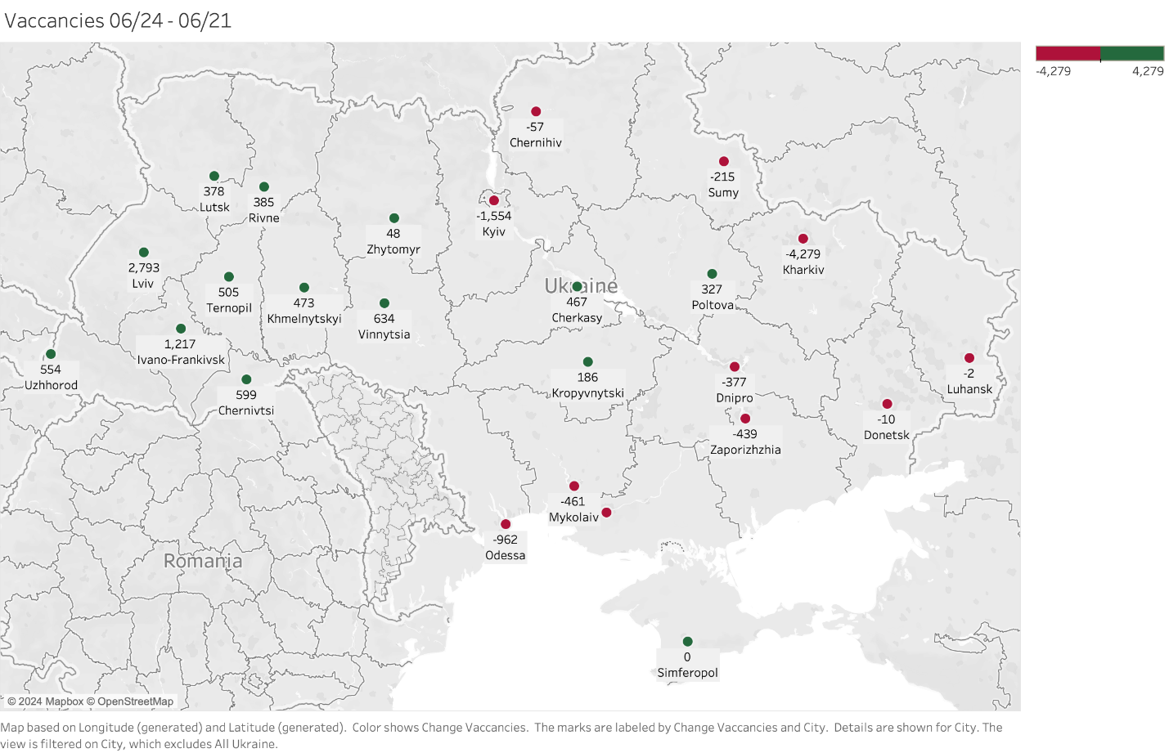

**Figure 2**

**Change in salary offers by major city: June 2021-June 2024**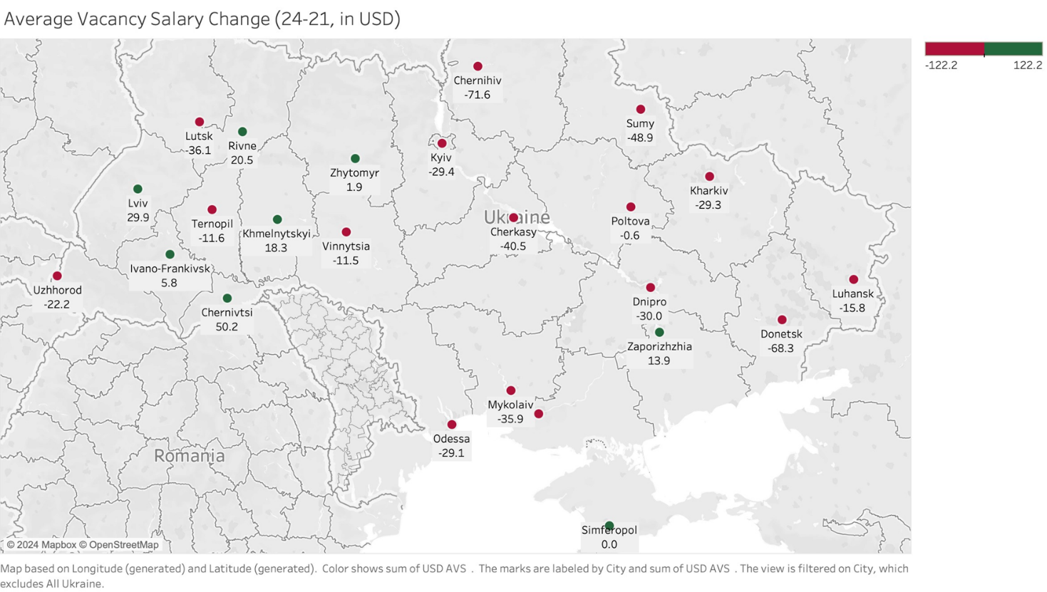

**Figure 4**

**Ukrainian vacancy (demand) and resume (sought) salary patterns, June 2021-June 2024**

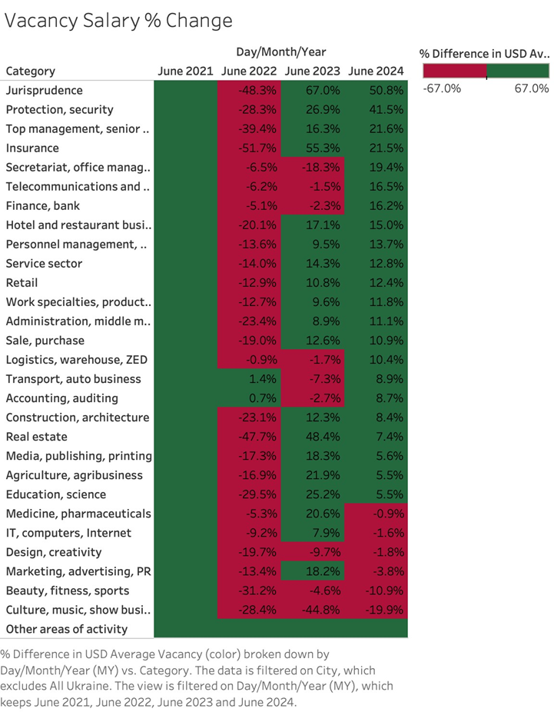

**Figure 4, cont.**

**Ukrainian vacancy (demand) and resume (sought) salary patterns, June 2021-June 2024**

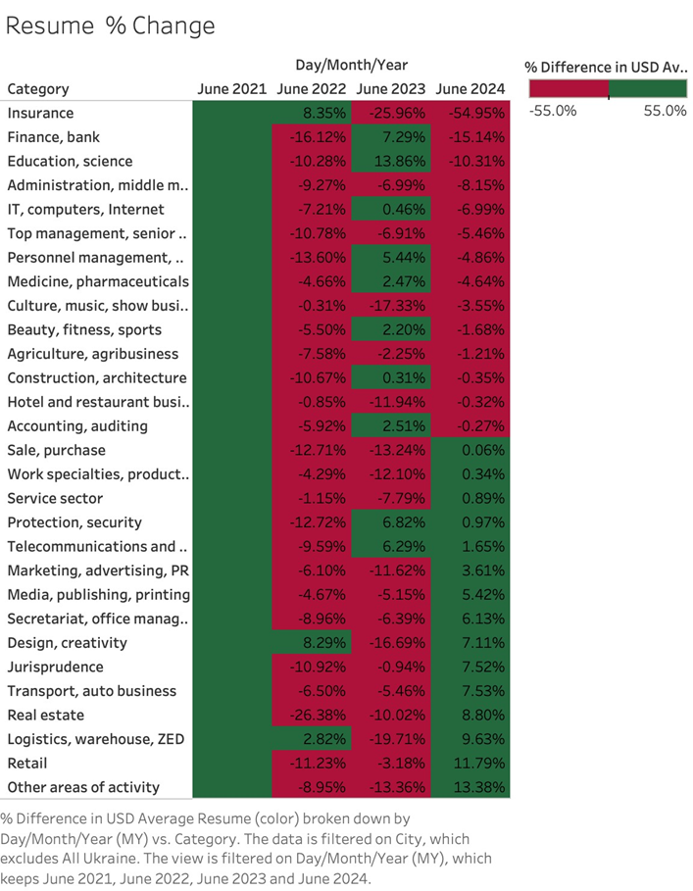

**Figure 5**

**Ukrainian labor demand: changes in total advertised vacancies by sector for Kyiv, Dnipro, Odesa, Kharkiv, and Zaporozhiya, 2021:I – 2024:I**

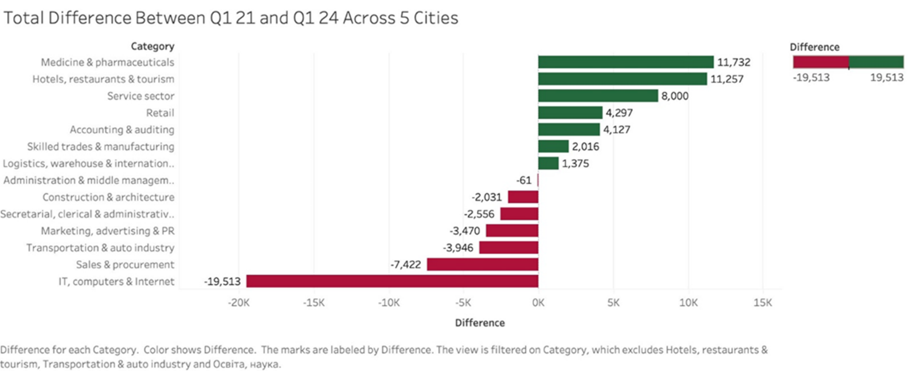

**Figure 6**

**Ukrainian vacancy (offered) salary patterns, by city June 2021-2022-2023-2024**

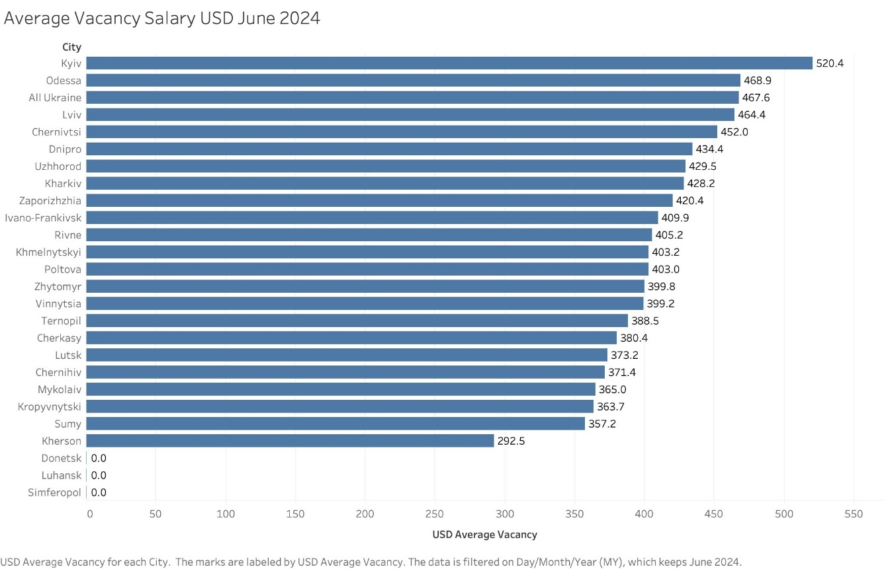

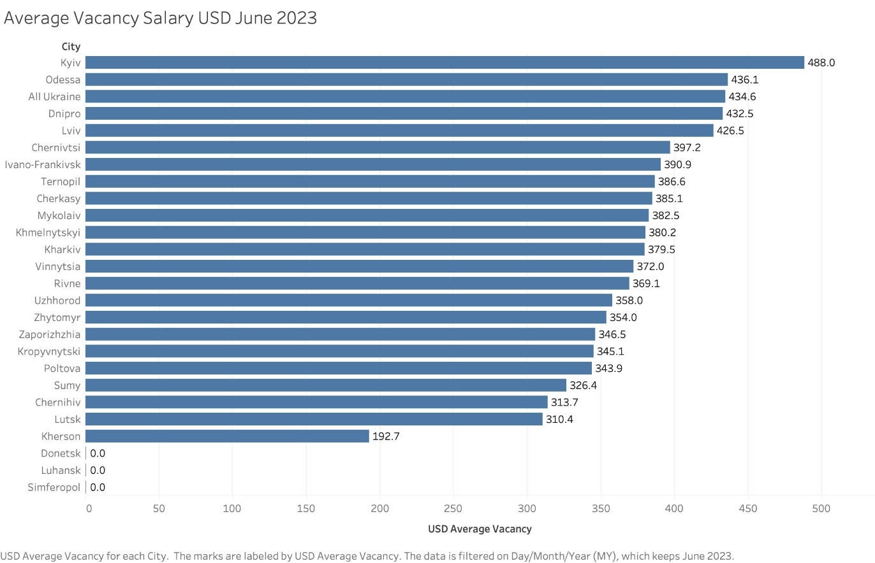

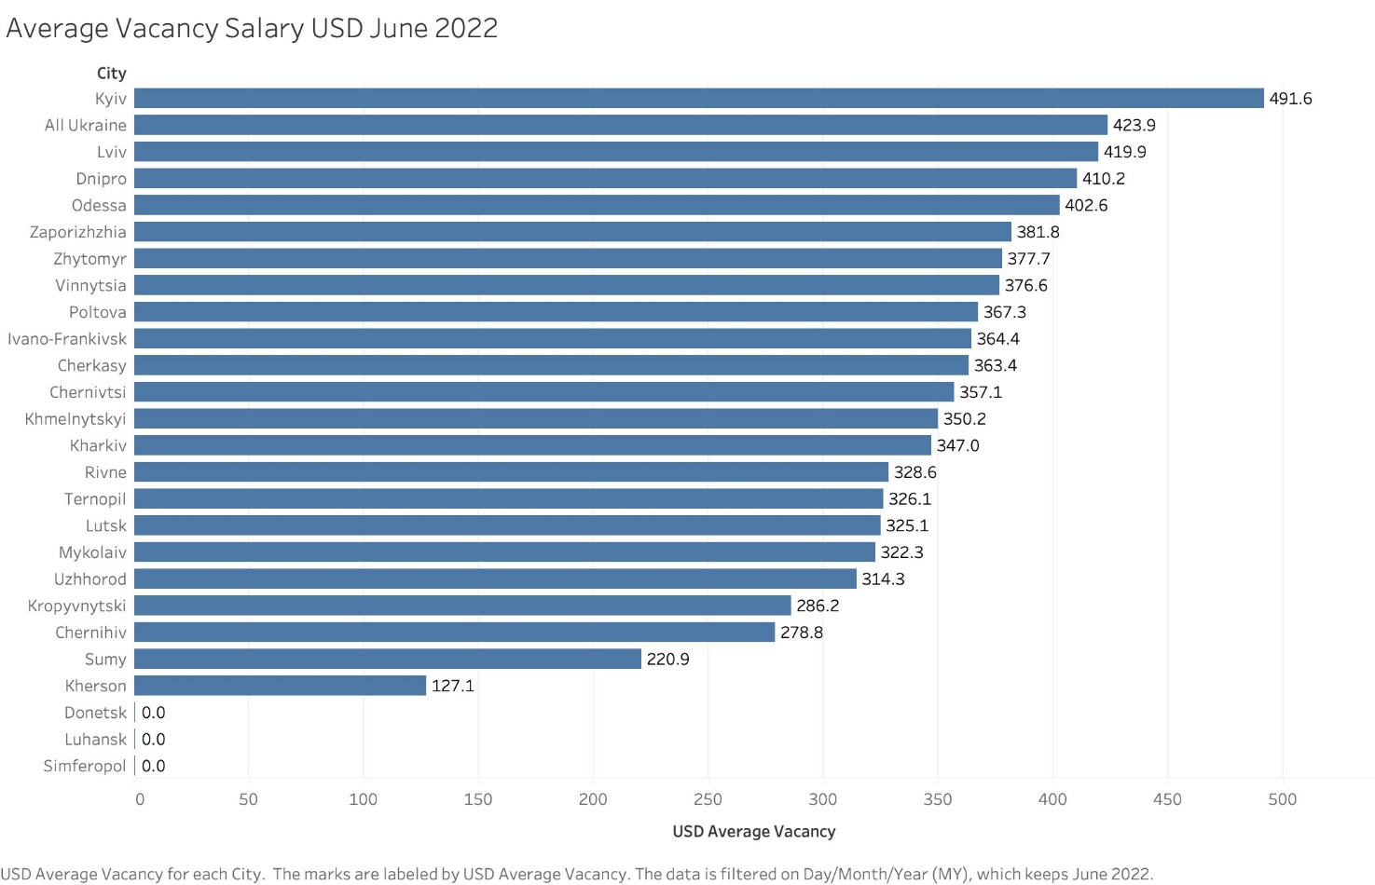

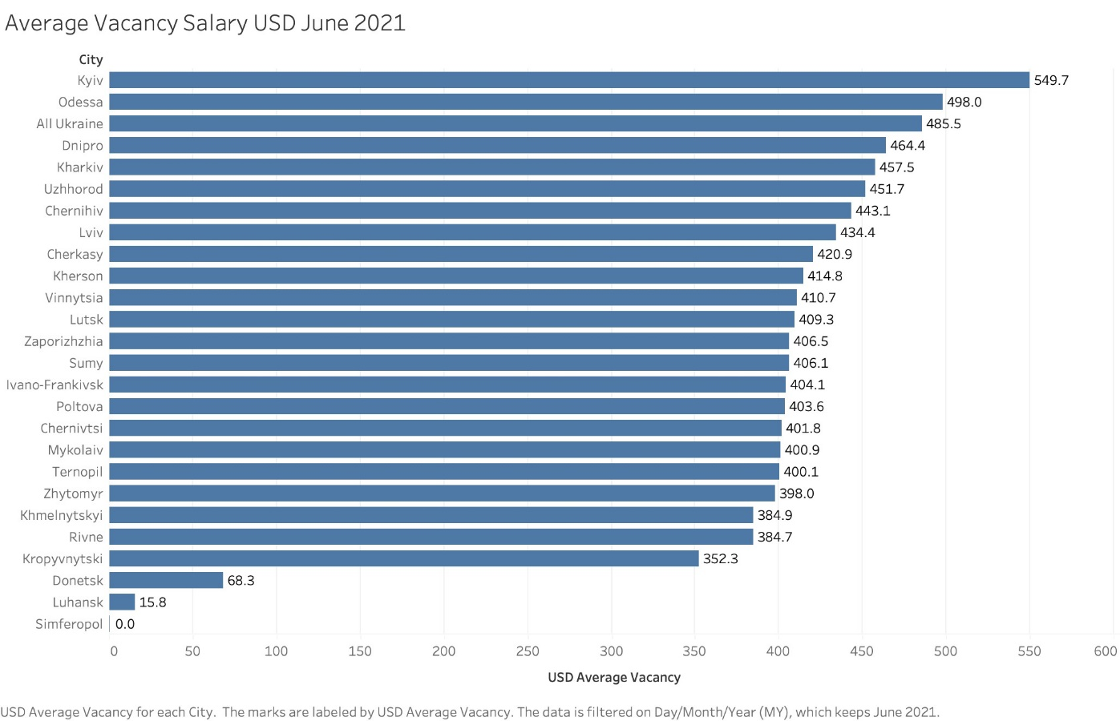

Finally, Figure 6 provides information on the mean values of employers’ monthly salary offers across cities for June in each of 2021-2024. Excluding Russian-occupied or threatened cities, the June 2024 mean values range from USD 357 in Sumy to USD 520 in Kyiv. However, Kyiv is something of an outlier, and all other monthly salaries are below USD 470.

There are several additional key takeaways from the detailed labor market data. First, the Ukrainian economy is not collapsing. 2022 was indeed a tremendous negative shock, with the number of offers collapsing (Figure 7) and mean offer values falling roughly by 13%, but the recovery since late 2022 has been dramatic as well. This is especially true in Lviv, where offered wages in 2024 substantially exceed 2021 values and even the 2022 decline was quite modest, and elsewhere in western Ukraine. While not exceeding the 2021 levels, recoveries in Kyiv and Odesa as well. In contrast, wage offers in threatened Sumy in the northeast fell by 45% between June 2021 and 2022, and even as of June 2024 remain 12% below the 2021 levels.

(**Eva: can you create a figure with weekly or monthly vacancies vs. resume postings for 2022-2023 like the one you did for Kharkiv, to replace Figure 7 below**)

**Figure 7**

**Kharkiv: new vacancies (red) and resumes posted (blue), 2022-2023, first week of each month**

 

Second, while the Ukrainian economy has picked up dramatically, salaries are far lower than in refugee destination countries. The staggering differences can be seen in Figure 8, which contrasts wages by occupation and city between Poland and Ukraine. US dollar wages in Polish cities are roughly four times as high as for their Ukrainian counterparts. This pattern also holds by occupation – except that in telecommunications the gap is a factor of 6, while it is just above 3 in hotels and restaurants.

Adding in the uncertainties of returning to a wartime nation, it is clear that compensating incentives will be important even after the fighting stops. Finally, to reiterate our earlier point, Ukraine is very much a wartime economy, and long-term recovery will require major investments in manufacturing, IT, and capital goods sectors, as well as in infrastructure.

**Figure 8**

**Average salaries, Polish and Ukrainian cities, by city and occupation, June 2024**

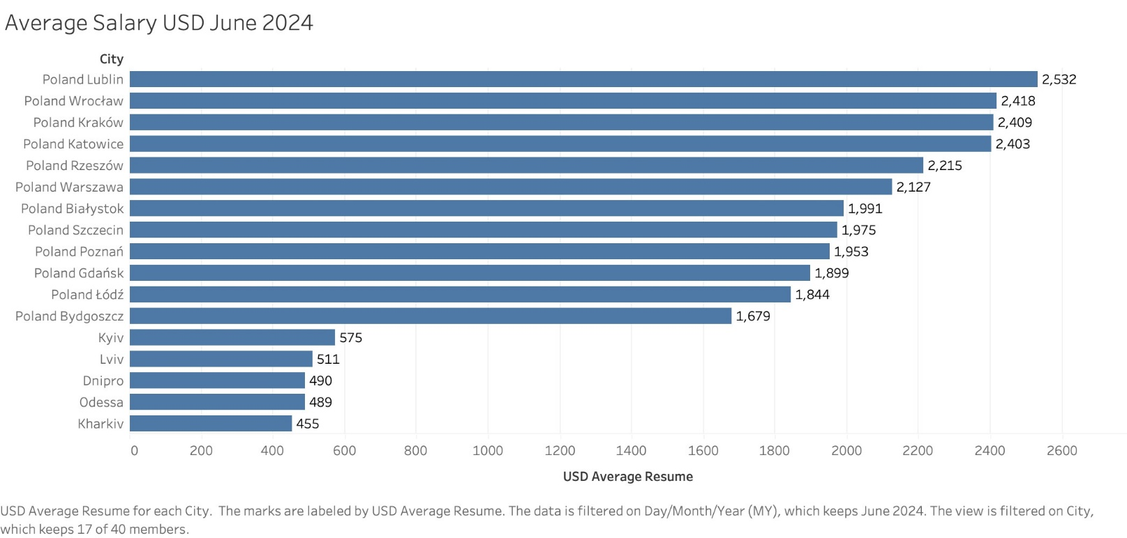

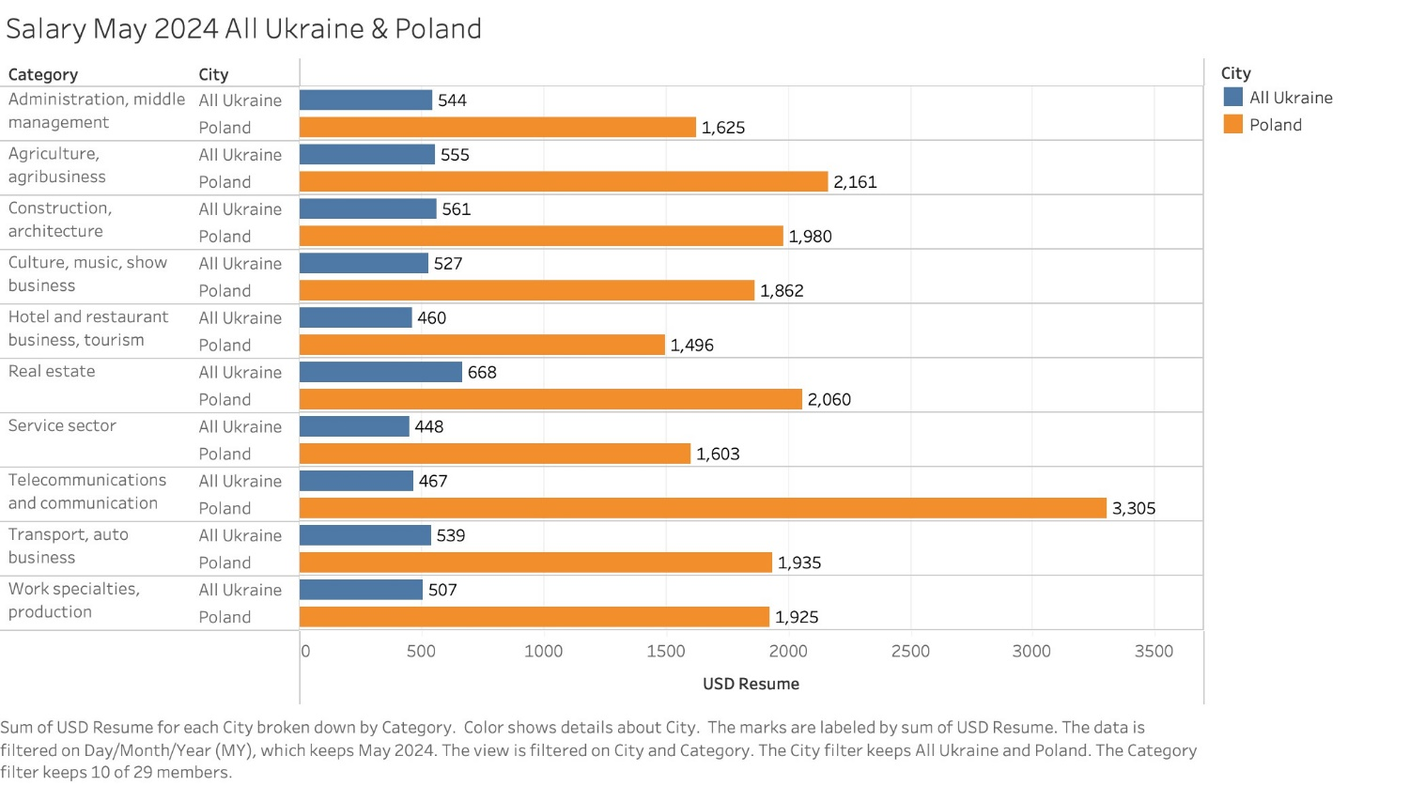

**Ukraine investment patterns and capital flows [to be written]**

1. **Currency boards – recent experience [to be written]**
2. **Airport re-opening and foreign direct investment – the empirical record**

This section seeks to obtain a broad sense of the potential economic value of reopening one of Ukraine’s two most important airports. To get at this, we first discuss the structure of Ukraine’s economy with reference to airport location. We then establish broad parameters related to the potential economic value of airports. Finally, we discuss the relative merits of reopening Lviv and Boryspil airports.

Ukraine’s exports of both goods and services are dominated by Kyiv, as are its imports. The immediately surrounding area adds to its dominance. Dnipropetrovska region to the east ranks second in terms of goods’ exports and third in terms of imports; Lviv is fourth in terms of goods exports and second in terms of imports. Vinnytsia, Chernivtsy, and Odesa to the south are all important, and are roughly equidistant from Lviv and Boryspil. Reopening airports in the eastern and southeastern industrial heartlands are impractical for security reasons.

Indeed, despite the economic dominance of Kyiv, the costs of reopening Boryspil Airport may be prohibitive at this time. While the airport itself can be defended against missile attacks and while deliberate attacks on civilian airliners are unlikely, the risk of mistaken identity is substantial, and the cost of insurance (and prospective passengers’ reluctance to fly) likely makes Boryspil infeasible. The relative attractiveness of Lviv is further enhanced by the ubiquity of rapid passenger train service from Lviv (all figures taken from <https://e-bilet.ua/en>)

**Passenger train time from Lviv to other Ukrainian cities**

**Destination**: **Trip duration**: (rounded to the nearest half hour)

Kyiv 6:30 – 7:00

Dnipro 6:00 (additional from Kyiv)

Ivano-Frankivsk 2:00

Kharkiv 13:30

Odesa 10:30

Poltava 14:30

Ternopil 1:30

Vinnytsia 4:30

It is true that not all major routes appear to be served as of June 2024. However, it also seems reasonable to anticipate that Ukrainian Railways would modify its schedules (and quality of service) with the reopening of Lviv Airport, and that a substantial portion of Ukraine would be within reasonable access.

To get an upper-bound sense of economic impact of airport reopening, we explore two empirical approaches using cross-country data. In neither case can we claim to have controlled for unobserved correlates of airport reopening, and it is likely that unobservables also have positive economic effects, thereby biasing up airport reopening coefficients.

To get an upper-bound sense of economic impact of airport reopening, we explore three empirical approaches using cross-country data. In neither case can we claim to have controlled for unobserved correlates of airport reopening, and it is likely that unobservables also have positive economic effects, thereby biasing up airport reopening coefficients.

The first approach involves simple linear regression of levels on levels, relating FDI to air passenger numbers, using quantile regression to focus on the magnitude of effects, followed by first differences (percentage changes) regressions. We obtain monthly flight data from the United States to all international destinations by US carriers for roughly the past three decades, from the [Bureau of Transportation Statistics](https://www.bts.gov/browse-statistical-products-and-data/bts-publications/data-bank-28im-t-100-and-t-100f-internationa-0). We also obtain annual macroeconomic data, including foreign direct investment estimates, for the same time period, from [World Bank Development Indicators](https://databank.worldbank.org/source/world-development-indicators). We fill in some data from Ukraine in 2023 from International Monetary Fund estimates (IMF Country Report No. 23/399). Finally, to hone in on the impact of flight resumptions on FDI in conflict areas, we obtain daily [ACLED conflict data](https://acleddata.com/data-export-tool/) and aggregate to the annual level for each country.

Total FDI for year *t* is then regressed on the **total number** of passengers flying into a country year *t-1* (transformed by ln (1 + number) due to the magnitude of passengers) and split into 10 deciles to investigate the effects at different passenger levels and, in effect, country size and level of economic development. This is our simplest regression, and the reopening coefficient was significant at all deciles except for the first (Table 1, Model 1), showing that with the base relationship, the relationship between passengers flying into a country on US carriers and FDI in that country grows stronger as there are more passengers flying in. While still not causal, that FDI increases with the passenger numbers associated with airport reopening is suggestive that the effect is likely to be more important in relatively large, developed economies.

Total FDI (Y) was next regressed on the **percentage change** in passengers flying into the country (X, transformed by ln (X+1) due to the magnitude of many changes), again binned by decile to investigate the effects at different X levels. Taking logarithms produces undefined values from negative values; we therefore restrict the data set, effectively narrowing the interval of study of the passenger numbers’ variable to just positive changes. As we are examining deciles, this restriction effectively means that we are omitting what would be the lowest deciles of the unrestricted passenger growth (X) variable, simply “zooming in” our analysis to the higher deciles. Significant and positive changes were observed for the middle 20-90% of the X variable (Table 2, Model 2), implying that the relationship between an increase in passengers flying into the country and total FDI **becomes more positive** with the magnitude of the percentage increase.

**Table 1**

**Decile OLS regressions of total FDI on quantity or percentage increase of passengers flying into a country, controlled by battle fatalities and GDP**

|  |  |  |  |  |  |  |
| --- | --- | --- | --- | --- | --- | --- |
| tau | X1 = ln_pass | coefficients1 | X1 = ln_passengers_pct | coefficients2 | coefficients3 | coefficients4 |
| 0.1 | Intercept | 31020000*** | Intercept | 36910000*** | 40870000*** | -113800000 |
| 0.1 | Coefficient | -2184000 | Coefficient | -7617000 | -7935000 | -231200000 |
| 0.2 | Intercept | 93940000*** | Intercept | 142500000*** | 143200000*** | -18840000 |
| 0.2 | Coefficient | 29790000*** | Coefficient | 83980000 | 83720000 | -19250000 |
| 0.3 | Intercept | 241600000*** | Intercept | 307200000*** | 305200000*** | 36880000* |
| 0.3 | Coefficient | 71060000*** | Coefficient | 299900000*** | 299700000*** | 18480000 |
| 0.4 | Intercept | 357500000*** | Intercept | 458500000*** | 472800000*** | 96630000* |
| 0.4 | Coefficient | 179800000*** | Coefficient | 507600000*** | 501500000*** | 70090000 |
| 0.5 | Intercept | 477600000*** | Intercept | 815500000*** | 9.18e+08*** | 167100000*** |
| 0.5 | Coefficient | 339500000*** | Coefficient | 951800000*** | 920500000*** | 205700000*** |
| 0.6 | Intercept | 716900000*** | Intercept | 1.229e+09*** | 1.357e+09*** | 223100000** |
| 0.6 | Coefficient | 615800000*** | Coefficient | 1.576e+09*** | 1.572e+09*** | 257200000*** |
| 0.7 | Intercept | 1.111e+09*** | Intercept | 1.843e+09*** | 2.059e+09*** | 504500000*** |
| 0.7 | Coefficient | 1.185e+09*** | Coefficient | 3.503e+09*** | 3.51e+09*** | 269700000*** |
| 0.8 | Intercept | 1.691e+09*** | Intercept | 3.595e+09*** | 4.541e+09*** | 9.67e+08*** |
| 0.8 | Coefficient | 2.194e+09*** | Coefficient | 6.586e+09*** | 6.488e+09*** | 366800000* |
| 0.9 | Intercept | 3.324e+09*** | Intercept | 1.758e+10*** | 2.114e+10*** | 2.144e+09*** |
| 0.9 | Coefficient | 4.452e+09*** | Coefficient | 1.435e+10*** | 1.512e+10*** | 1.116e+09* |
| 1 | Intercept | 1.457e+11*** | Intercept | 2.611e+11*** | 3.28E+11 | 6.85e+10*** |
| 1 | Coefficient | 1.64E+10 | Coefficient | 4.90E+10 | 3.14E+09 | 3.417e+10. |
| *\* The passengers variable, or X1, is defined as the natural log of passengers flying into the country (ln_pass) or percentage change in passengers flying into the country from the previous year (ln_passengers_pct), adding +1 before the log to account for entries of 0, which would otherwise produce an undefined result. This is split by decile in the “tau” column.*  *Note that negative values are not expressed due to the log transformation producing -Inf values. As we are examining deciles, this restriction effectively means that we are omitting what would be the lowest deciles of the unrestricted passenger growth (X) variable, simply “zooming in” our analysis to the higher deciles.*  *Significance: *** p<0.001; ** p<0.01; * p<0.05; . p<0.1*  *1 This regression estimates the following relationship: Total FDI = β1*ln_pass + ε*  *2 This regression estimates the following relationship: Total FDI = β1*ln_passengers_pct + ε*  *3 This regression estimates the following relationship: Total FDI = β1*ln_pass + β2*ln_battle_fatalities + ε*  *β2 (not reported) is the coefficient on X2, ln_battle_fatalities (the natural log+1 of battle fatalities).*  *4 This regression estimates the following relationship: Total FDI = β1*ln_pass + β2*ln_battle_fatalities + β3*total_GDP + ε*  *β3 (also not reported) is the coefficient on X3, total_GDP (in terms of current $US).* | | | | | | |

This relationship between the lagged logarithm of passenger levels and current FDI holds even when controlling for the natural logarithm of battle fatalities (drawn from ACLED data from that same year and country) (Table 3, Model 3), though is again only significant for the middle 20-90% of the X1 (log of increase in passengers) variable.

Finally, the relationship holds even when controlling for GDP in terms of current (2022) USD, though it is only significant for the latter 40-100% deciles of the X1 (log of increase in passengers) variable (Table 4, Model 4). Please note the spike in the beta at the end, which is significant for the passengers’ variable. In sum, there is a clear link between passenger numbers or growth and FDI, even controlling for conflict intensity and GDP. However, since airlines have an incentive to increase flights to countries with surging economies (and hence greater FDI), we observe correlation rather than causation.

The second approach was a multivariate OLS analysis, observing the robustness of this effect subject to **different GDP measurements**. For this analysis, we implemented an IHS transformation on the FDI variable instead of a log+1 transformation. Due to the shape of the function, this serves both to include negative datapoints in the model and smooth out the marginal effect of changes at both extremes.

First, we ran a series of models, testing the durability of the association between the independent variable (log+1 percentage increase in flights) and the key dependent variable (IHS-transformed real FDI) when isolating different versions of the GDP covariate. While the association was not significant in more than one model (the European geographic subset reported below), this is likely owing to the IHS transformation itself, which produces a wide gap between large negative and large positive datapoints, making OLS residuals much larger. This may also be due to the small magnitude of the resulting estimates, falling at between 0.0004 and 0.001 in the below specifications. However, some of the models produced joint significance of the dependent variables, which shows the strength of passengers as a predictor in conjunction with both logged real GDP in USD and logged nominal GDP in international dollars. Most optimistically, we also see that the models were consistent with each other—each estimated approximately 8-11% FDI growth to be associated with a 200% increase in flights. For the below specifications, none of the coefficients were negative, despite being so close to zero, indicating precision of this estimated effect.

**Table 2**

**OLS regressions of Percentage change FDI on passengers flying into the country**

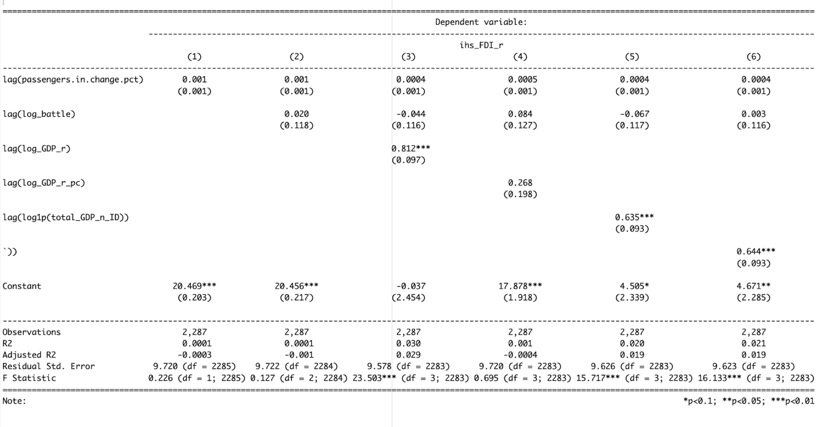

As robustness checks, we ran the same models with different relevant subsets of countries (European countries, Lower Middle Income Countries as specified by the World Bank, and Middle Income Countries also specified by the World Bank). The estimates were also consistent with the IHS-transformed real FDI estimates. For instance, see below the output produced from an N=689 subset of the dataset **focusing on only European countries**. Here, we see the estimated effect is consistent with other models at approximately 8-11% FDI growth associated with a 200% increase in flights (the estimate is reported as 0.000 in this table, but in reality is approximately 0.0004-0.0005). However, the consistently positive FDI and passenger variables in Europe may have been the reason for the significance of the model, and bodes well for Ukraine specifically.

**Table 3**

**OLS regressions of Percentage change FDI on passengers flying into the country, controlling for battle fatalities using IHS-transformed real FDI, subsetting the data to include European countries only**

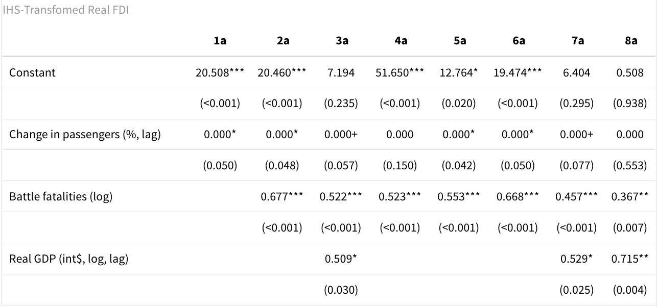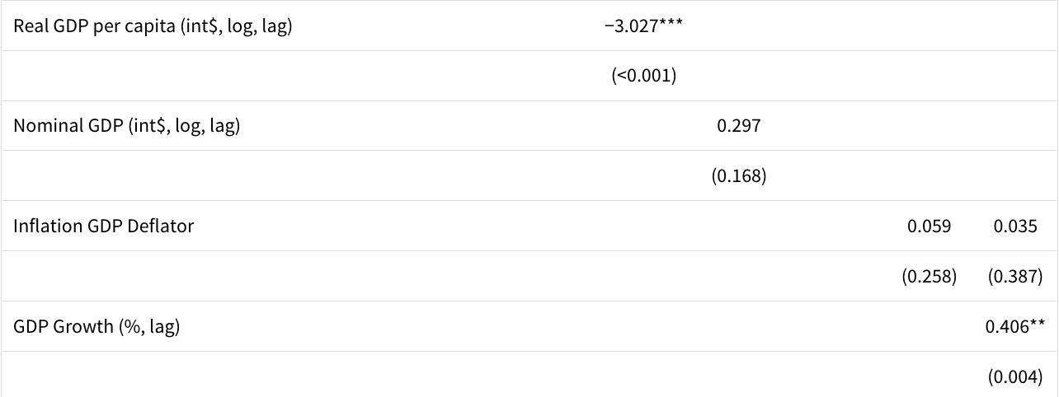

Lastly, we ran the model with log-transformed FDI as the independent variable. This produced negative estimates, revealing that the negative FDI datapoints excluded by this method are consequential to the resulting estimators, and that the IHS transformation is useful. Also note that studentized Breusch-Pagan tests were run to test heteroskedasticity, and none was observed in the reported models.

The third approach involves a **difference-in-differences specification**. We regress the IHS transformation of FDI on battle fatalities, GDP, the interaction between ln battle fatalities (plus 1) and a treatment variable (coded as “1” for any year after the largest percentage increase in a country's air traffic, given that the amount increases by at least 150%, of which there are only 28 countries in the dataset where this is the case between 2010-2019), and the post-treatment variable (the number of years after the first treatment year).

**Table 4**

**DiD regressions of Percentage change FDI on passengers flying into the country, controlling for battle fatalities using transformed real FDI**

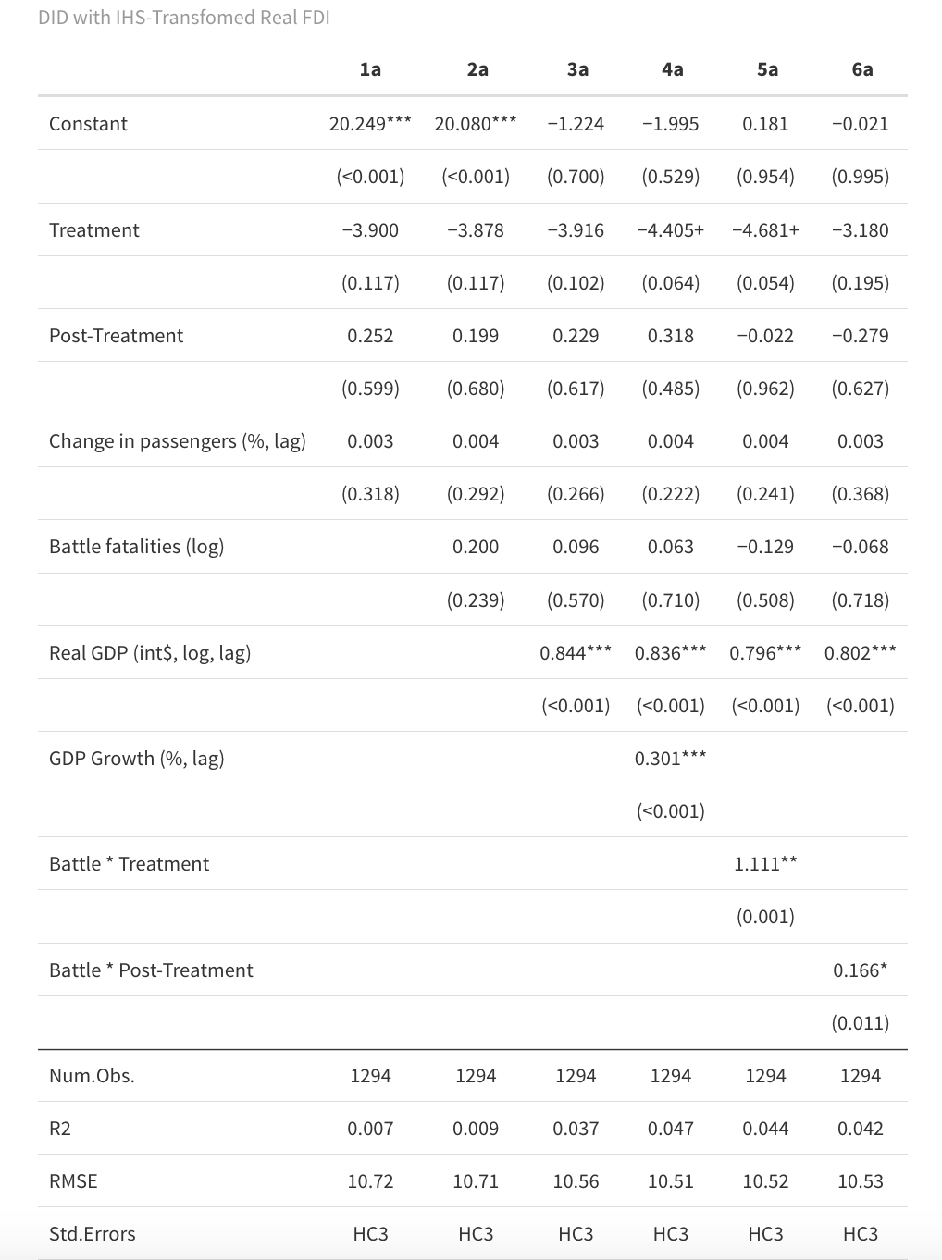

The treatment variable (and its interaction with subsequent year terms) comes far closer to capturing a large air traffic shock, given our magnitude restriction. The significant treatment interaction with battle fatalities links the shock to a war-related event, and the significant post-treatment interaction variable indicates that this positive relationship between a shock and FDI remains positive, yet declines somewhat, in post-shock years. The negative coefficient on the treatment and post-treatment variables without the interaction also indicates that the positive relationship seems to be dependent on a war environment with more battle fatalities.

Agree – I’ll add a “percent change in battle fatalities” variable as an additional robustness check and potentially put the table in the appendix.

**Bottom line**: contemporaneous and lagged air traffic is associated with increased foreign direct investment, especially for countries/airports with modest traffic. Beyond omitted variables and endogeneity, the obvious criticism of this approach is that the terms are likely cointegrated (**we need to provide cointegration tests**), limiting claims to having uncovered causal inference. However, the positive significance of an air traffic surge in areas with high battle fatalities on FDI seems more likely to be unidirectional: it seems unlikely that FDI has a non-idiosyncratic causal impact on battle fatalities.

Next steps might include adding prior trends: although the difference-in-differences design ensures that there is a big airport passenger jump at t=0, **showing an absence of prior trends in GDP is still important**. The obvious approach is to show that lagged GDP does not exhibit a strong prior trend: if it does, then we need to **de-mean growth rates (and include country fixed effects to correct for levels, or possibly do two-way fixed effects)**.

Yet another problem is with potential selection bias: our empirical work focuses on countries where there is one primary airport and that it reopens cleanly after some period in the observed time series. **Need appendix tables with list and years of countries in data; descriptive statistics**.

Finally: **add citations** where appropriate. And **provide estimates for a sample limited to, say, Europe and MENA (Middle East & North Africa**.

1. **Concluding remarks**

Earlier in 2024, the World Bank (2024) and partners estimated that the costs of “reconstructing Ukraine” – and not considering any future damage – came to USD 485 billion (or about 265 percent of Ukraine’s 2023 GDP). We do not take issue with this estimate. Indeed, given ongoing and future damages, as well as foregone GDP and the economic value of lives lost, this is obviously a large underestimate of the true damage.

Given that the war continues unabated, the primary focus on arms and other military support to Ukraine is entirely appropriate. So, too, is recognition of the physical damage done, along with estimating rebuilding costs. In addition, we have sketched a series of measures intended to leverage international infrastructure support and debt relief, and to create incentives for private capital investments and repatriation of refugees.

Beyond the obvious complementarities of the incentive measures discussed above, we expect that they are relatively inexpensive. Most importantly, to a large extent they can be implemented immediately while the war continues. This has signaling value – to displaced Ukrainians and those who have not left, to prospective investors, and to the Russian government. Russia is counting on “Ukraine fatigue” in the international community: the measures sketched above all indicate that Ukraine’s supporters are standing firm.

The measures sketched above are not detailed. It is far too early to “get lost in the weeds” with intricate detail, and such detail must engage and incorporate Ukrainian voices as well. In addition, the discussions that must follow as specific proposals emerge contain valuable signaling value as well. Moreover, because the *can* be implemented in the not-too-distant future, the initially rather abstract incentives are actually more concrete than discussions of reparations (though not provision of arms or demining efforts).

DO:

* Incorporate Aaron’s materials
* Review Vox Ukraine papers
* Review Gorodnichenko 2022 volume
* Check IMF, World Bank, EBRD reports
* Lit review on currency board advice
* Go through [www.opendatabot.ua](http://www.opendatabot.ua) (Charlie, Eva)

**References**

Alcock, Charles, “Doubts Raised over Possible Ukrainian Airspace Reopening,” *AIN Online*, March 15, 2024, <https://www.ainonline.com/aviation-news/air-transport/2024-03-15/doubts-raised-over-possible-ukrainian-airspace-reopening>

Alexander, Monica, Kivan Polimis, and Emilio Zagheni. "The impact of Hurricane Maria on out-migration from Puerto Rico: Evidence from Facebook data." *Population and Development Review* (2019): 617-630.

Anastasia, Giacomo, Tito Boeri, Marianna Kudlyak, and Oleksandr Zholud, “The labour market in Ukraine: Rebuild better,” Ch. 10 in Gorodnichenko et al. (2022)

Bahar, Dany, Andreas Hauptmann, Cem Özgüzel, and Hillel Rapoport. "Migration and knowledge diffusion: The effect of returning refugees on export performance in the former Yugoslavia." *Review of Economics and Statistics* (2024): 1-18.

Camba, Alvin. "Inter-state relations and state capacity: the rise and fall of Chinese foreign direct investment in the Philippines." *Palgrave Communications* 3.1 (2017): 1-19.

Cazbat, Christelle and Marco Tucci. “Unveiling the cost of internal displacement - The ripple effect: economic impacts of internal displacement.” Internal Displacement and Monitoring Centre. 2019 (February) [201902-economic-impact-cost-estimates.pdf (internal-displacement.org)](https://api.internal-displacement.org/sites/default/files/publications/documents/201902-economic-impact-cost-estimates.pdf)

Chimni, Bhupinder S. "Refugees and post-conflict reconstruction: A critical perspective." *Recovering from Civil Conflict*. Routledge, 2014. 163-180.

Gao, Ge, Alex Nikolsko-Rzhevskyy and Oleksandr Talavera, “ A central bank's voice rising above the roar of gunfire,” CEPR-Vox EU, 10 January 2024, <https://cepr.org/voxeu/columns/central-banks-voice-rising-above-roar-gunfire>

Gorodnichenko, Yuriy, Ilona Sologoub, and Beatrice Weder, eds. *Rebuilding Ukraine: principles and policies*. CEPR Press, 2022.

Herbst, John, Olga Khakova, and Charles Lichfield, [Reconstructing-Ukraine-at-war:the-journey-to-prosperity-starts-now](https://www.atlanticcouncil.org/in-depth-research-reports/report/reconstructing-ukraine-at-war-the-journey-to-prosperity-starts-now/?mkt_tok=NjU5LVdaWC0wNzUAAAGTl1i9q2c0Yp9qMFNyfX_my6I_sxBzWtwuK0nBePjiX5EmfMPrnwp6FoAazVVP77ifOLUhpR93My-Zkm2HPRrYVZDZNBRXe2v-SOj5okiyd58Y) (Atlantic Council, May 2024).

Hinojosa, Jennifer, and Edwin Meléndez. "Puerto Rican exodus: One year since hurricane Maria." *Center for Puerto Rican Studies* (2018).

Internal Displacement Monitoring Centre. “The ripple effect: economic impacts of internal displacement.” (n.d.). <https://api.internal-displacement.org/sites/default/files/publications/documents/201902-economic-impact-cost-estimates.pdf>

International Labour Organization (ILO) *How did the war impact the Ukrainian labour market?* (2024, January 24). <https://www.ilo.org/resource/news/how-did-war-impact-ukrainian-labour-market>

International Monetary Fund (IMF), “IMF Executive Board Completes the Fourth Review of the Extended Fund Facility Arrangement for Ukraine,” June 28, 2024 <https://www.imf.org/en/News/Articles/2024/06/28/pr24252-ukraine-imf-exec-board-completes-4th-rev-eff-arr>

Khadaroo, A. J., and B. Seetanah. "Transport infrastructure and foreign direct investment." *Journal of International Development: The Journal of the Development Studies Association* 22.1 (2010): 103-123.

Kobilov, Botir, “Technology-related development.” Harvard Business School. PhD job market paper, December 2023.

Lachman, Desmond, “Does Ukraine really need a currency board?” *The Hill*, May 13, 2014 <https://www.aei.org/articles/does-ukraine-really-need-a-currency-board/>

Le, Quan Vu, and Paul J. Zak. "Political risk and capital flight." *Journal of International Money and Finance* 25.2 (2006): 308-329.

Loschmann, Craig, Christopher R. Parsons, and Melissa Siegel. "Does shelter assistance reduce poverty in Afghanistan?." *World Development* 74 (2015): 305-322.

Libanova, Ella. “Ukraine’s plans for demographic recovery.” Washington, DC: Wilson Center, Kennan Cable no. 88. February 24, 2024. <https://www.wilsoncenter.org/sites/default/files/media/uploads/documents/KennanCable_88.pdf>

Libanova, Ella. «Дай боже, щоб до 2035 року нас було 30 мільйонів» (“Pray that in 2035 Ukraine will have 30 million people.”) (interview with Sonya Koshkina, Executive Editor, [www.lb.ua](http://www.lb.ua) August 13, 2023), <https://lb.ua/news/2023/08/21/570946_ella_libanova_day_bozhe_shchob_2035.html>

Marandici, Ion. "Oligarchs, Political Ties and Nomenklatura Capitalism: Introducing a New Dataset." *Europe-Asia Studies* (2024): 1-31. <https://mpra.ub.uni-muenchen.de/120709/>

Movchan, Veronika and Kenneth Rogoff, “International trade and foreign direct investment,” Ch 5. In Gorodnichenko et al. (2022).

Mwesigye, Francis. "COVID-19 Implications on private investment and markets in East Africa: A rapid assessment." (2021).

Olariaga, Oscar Díaz, and Carlos Alonso‐Malaver. "Impact of airport policies on regional development. Evidence from the Colombian case." *Regional Science Policy & Practice* 14.6 (2022): 185-211.

Peres, Mihaela, Waqar Ameer, and Helian Xu. "The impact of institutional quality on foreign direct investment inflows: evidence for developed and developing countries." *Economic research-Ekonomska istraživanja* 31.1 (2018): 626-644.

Pradhan, Rudra P. "Investigating the causal relationship between transportation infrastructure, financial penetration and economic growth in G-20 countries." *Research in Transportation Economics* 78 (2019): 100766.

Prata, Ndola, Amita Sreenivas, Farnaz Vahidnia, and Malcolm Potts. "Saving maternal lives in resource-poor settings: facing reality." *Health Policy* 89, no. 2 (2009): 131-148.

Rapoport, Hillel, Andreas Hauptmann, Cem Ozguzel, and Dany Bahar, “Migration and post-conflict reconstruction: The effect of returning refugees on export performance in the former Yugoslavia,” CEPR-Vox EU, 22 November 2019 [Migration and post-conflict reconstruction: The effect of returning refugees on export performance in the former Yugoslavia | CEPR](https://cepr.org/voxeu/columns/migration-and-post-conflict-reconstruction-effect-returning-refugees-export)

REYN Ukraine. (2019, November 29). <https://www.reyn.eu/national_networks/ukraine/#:~:text=According%20to%20the%20mentioned%20survey,Roma%20in%20Ukrainian%20are%20disadvantaged>

Rupp, Nicholas G., George M. Holmes, and Jeff DeSimone. "Airline schedule recovery after airport closures: Empirical evidence since September 11." *Southern Economic Journal* 71.4 (2005): 800-820.

SSS Stabilization Support Services/Access (to multisectoral humanitarian assistance project, funded by the EU) [Report on Employment and Economic Integration Situation of Internally Displaced Persons [EN/UK] - Ukraine | ReliefWeb](https://reliefweb.int/report/ukraine/report-employment-and-economic-integration-situation-internally-displaced-persons-enuk), October 2023.

Serrano, Francisco, and Antonín Kazda. "The future of airports post COVID-19." *Journal of Air Transport Management* 89 (2020): 101900.

SkyUp Airlines. May 1, 2024. <https://skyup.aero/en/news/it-would-be-untrue-say-airport-ukraine-possible-soon-tomorrow-oleksandr-shafiev-top-manager-skyup-airlines_480>

Sologoub, Ilona. “Де взяти гроші на ваші ідеї? Як міжнародні фінансові інституції підтримують український бізнес” (Where to get money for your ideas? How international financial institutions support Ukrainian business). VoxUkraine, June 5, 2024a. [Де взяти гроші на ваші ідеї? Як міжнародні фінансові інституції підтримують український бізнес (voxukraine.org)](https://voxukraine.org/de-vzyaty-groshi-na-vashi-ideyi-yak-mizhnarodni-finansovi-instytutsiyi-pidtrymuyut-ukrayinskyj-biznes)

Sologoub, Ilona. “Return or stay? What factors impact the decisions of Ukrainian refugees? VoxUkraine January 16, 2024b. [Return or stay? What factors impact the decisions of Ukrainian refugees (voxukraine.org)](https://voxukraine.org/en/return-or-stay-what-factors-impact-the-decisions-of-ukrainian-refugees)

Turulja, Lejla, Melika Husić-Mehmedović, and Adnan Efendic. "Emigration in Bosnia and Herzegovina: Empirical Evidence from the Last Two Decades." *Central and Eastern European Migration Review* 12.2 (2023): 53-72

Tverdostup, Maryna. *The demographic challenges to Ukraine's economic reconstruction*. No. 71. Vienna: WIIW Policy Notes and Reports, 2023. <https://wiiw.ac.at/the-demographic-challenges-to-ukraine-s-economic-reconstruction-p-6620.html>

Volosevych, Inna, “The economic effects of Russia’s was on Ukraine’s internally displaced women.” ZOiS (Zentrum fur Osteuropa und international Studien/Centre for East European and International Studies (26/07/2023) [The Economic Effects of Russia’s War on Ukraine’s Internally Displaced Women (zois-berlin.de)](https://www.zois-berlin.de/en/publications/zois-spotlight/the-economic-effects-of-russias-war-on-ukraines-internally-displaced-women#:~:text=As%20a%20result%20of%20the%20massive%20job%20losses%2C%20Ukraine's%20internally,local%20men%20(figure%202).)

West, Jocelyn. "Social vulnerability and population loss in Puerto Rico after Hurricane Maria." *Population and Environment* 45.2 (2023): 8.

World Bank, Ukraine: rapid damage and needs assessment (RDNA3): February 2022-December 2023. Washington, DC: World Bank, Government of Ukraine, European Union, and United Nations. Updated February 15, 2024. <https://www.worldbank.org/en/news/press-release/2024/02/15/updated-ukraine-recovery-and-reconstruction-needs-assessment-released>

World Bank, “[Uzbekistan Tax Reform Support : Diagnosis, BPR, and Compliance Component - Annex 2.7 : STC (Diamond) Consolidated Recommendations (worldbank.org)](https://documents.worldbank.org/en/publication/documents-reports/documentdetail/099051024053540944/p16821017659b6071b32b180dad6cbf6f6),” 2023

Zaika, Nataliia, and Volodymyr Vakhitov, *A Way Home: returning intentions of Ukrainian refugees and migrants*, Kyiv: American University Kyiv, May 2024

1. Becker: Department of Economics, Duke University; International Academic Board, Kyiv School

   of Economics; and Friends of Ukraine Network

   Devine: Department of Economics, Boston College

   Lam, Schultze, and Spektorov: Department of Economics, Duke University

   Queen: Board of Directors, US-Ukraine Foundation
2. For an excellent discussion of these strategic needs, see Herbst,et al. (2024).
3. The [Wikipedia site *Child_abductions_in_the_Russo-Ukrainian_War*](https://en.wRWikipedia.org/wiki/Child_abductions_in_the_Russo-Ukrainian_War) provides excellent detail. For details on the Russian government claim see <https://www.currenttime.tv/a/v-rossiyu-vyvezli-bolee-700-tysyach-ukrainskih-detey/32527102.html> (*Nastoyashchee Vremya* 31 July 2023). See also the *Nastoyashchee Vremya* 16 February documentary by Olga Beshley and Yevgeniya Taganovich <https://www.currenttime.tv/a/lenin-stalin-putin-rossii-set-lagerey-perevospitaniyu-ukrainskih-detey/32273251.html> "*Это делали Ленин, Сталин, а сегодня – Путин". В России действует сеть лагерей по "перевоспитанию" детей, силой вывезенных из Украины*” (This was done by Lenin, Stalin, and today Putin, Russia is operating a network of re-education camps for children forcibly removed from Ukraine). The official Ukrainian government website <https://childrenofwar.gov.ua/> lists 19,546 children as deported/forcible displaced according to Ukrainian data, and over 744,000 as having been deported according to the Russian National Information Bureau. Note that Ukraine does not have data for fully occupied areas. Some 388 children are listed as having been returned.
4. For a remarkable dataset on oligarchs throughout the former USSR that has just become available, see Marandici (2024).
5. <https://meduza.io/news/2024/08/03/agentstvo-s-p-ponizilo-reyting-ukrainy-do-vyborochnogo-defolta>. The article also notes that 2026 euro obligations are rated “D” (default), and other priority non-guaranteed debt emissions are rated “CC” (high likelihood of default). Fitch rating agency at the end of July lowered Ukraine’s foreign currency debt to “C” (default inevitable).
6. Both Russia and Texas had 2023 GDP/GSPs of USD 2.02 trillion (and are oil states ruled by unstable, aggressive, nationalist governments with swirling corruption scandals). The main differences between Russia and Texas appear to be Russia’s pro- (and Texas’s anti-) immigration stance, and the fact that Texas already has an [Odessa](https://www.odessa-tx.gov/) of its own, and therefore does not need to threaten [Odessa, Kansas](https://www.bestplaces.net/city/kansas/odessa) (population: 34), or Kansas more broadly.